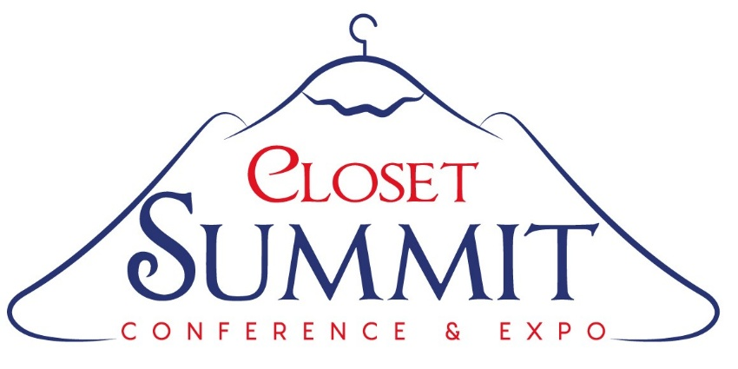
Grandover Resort ~ Greensboro, NC

Tentative Itinerary as of March 23, 2026
Monday ~ 10-26:
~ Optional CIA Invitational Golf Tournament
Tuesday ~ 10-27:
~ SEALS Teams lunch and 4-hour confidential strategy sessions
~ Assorted round table break-outs for non-SEALS
~ Four-hour networking Vendorama Extravaganza Meet, Greet & Eat Happy Hour(s)
Wednesday ~ 10-28:
~ Networking buffet breakfast and lunch
~ Educational Product Knowledge Series by our vendor sponsors
~ Closet University Discussions on AI and leading industry trends
~ Sales & Design Track presentations
~ Production & Operations Track discussions
~ Marketing and Advertising Track seminars
~ Administration & Financial Track panels
~ Installation Jubilation Collaboration Celebration
~ Timely Round Table Discussion Series
~ Tour: Dream Closets showroom/manufacturing facility with dinner
Thursday ~ 10-29:
~ Networking buffet breakfast
~ Three top tier industry keynote speakers
~ Tour of Hafele's new Design Center, new Lighting Display Exhibit, State-of-the-art order processing center, Service+ facility and lunch
~ 4pm Shuttle to the airport or back to the hotel

